**Experiment No.: 3 Date: 07-03-2023**

**AIM**: Familiarization of linux commands.

**CO2**: Perform system administration task.

**Procedure:**

1. pwd : The pwd command is used to display the location of the current working directory.

$pwd

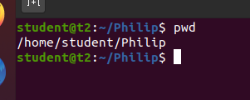

2. ls -The [ls](https://www.javatpoint.com/linux-ls) command is used to display a list of content of a directory.

$ls

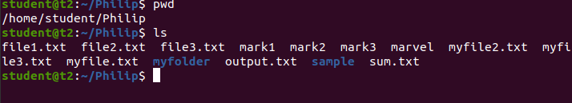

2.1 ls -R - prints subdirectory contents

$ls -R

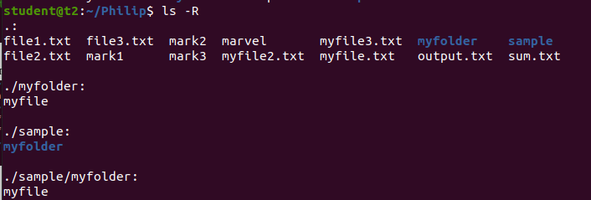

2.2 ls -l - long listing

$ls -l

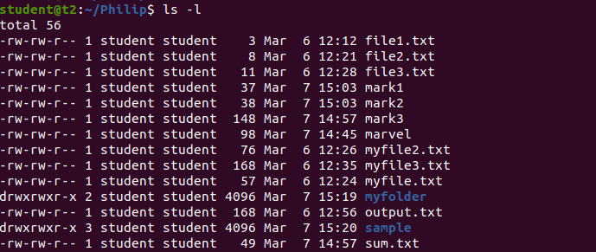

2.3 ls -a: to list all hidden files

$ ls -a



2.4 ls -al: list the files and directory with detailed information

$ls -al

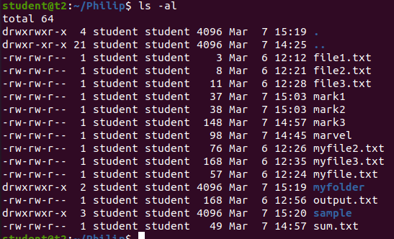

2.5 ls -t : list the file sorted in the order of the last modified file.

$ls -t



2.6 ls -r: to reverse the natural sorting order

$ls -r

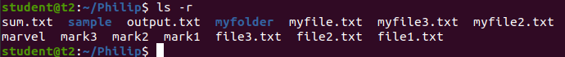

3.history – history of previous commands executed

$history

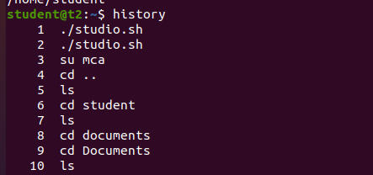

4. Man command --man followed by the name of the command or utility that you want to learn more about.

$man ls

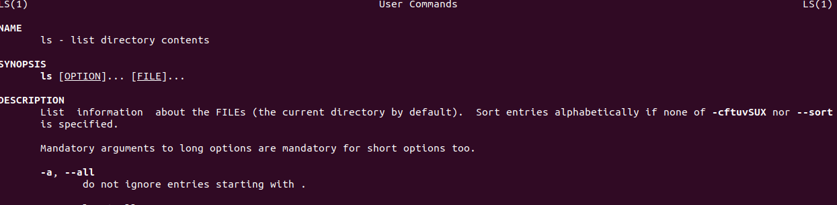

5.mkdir - To make a new directory

$mkdir

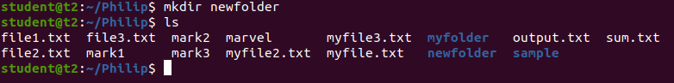

6.rmdir – To remove a directory

$rmdir

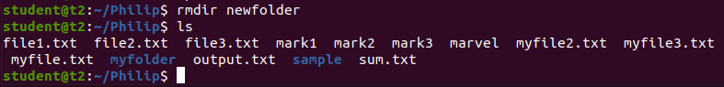

7.touch – The [touch](https://www.javatpoint.com/linux-touch) command is used to create empty files. We can create multiple empty files by executing it once.

$ touch file1.txt

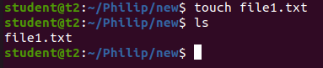

8.cat– The [cat](https://www.javatpoint.com/linux-cat) command is a multi-purpose utility in the Linux system. It can be used to create a file, display content of the file, copy the content of one file to another file, and more.

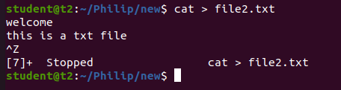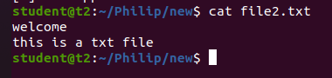

1. To append a file

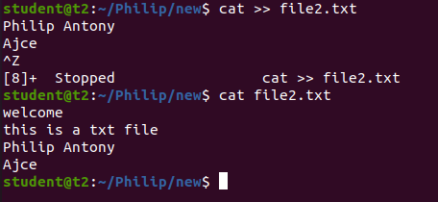

1. Merge two files

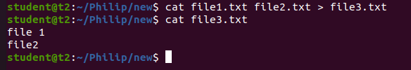

1. List lines of a file along with number

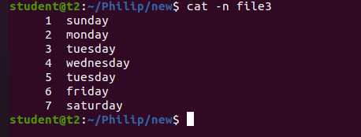

d)List files lines along with number discard numbering for empty lines

cat file1 file2 > file3

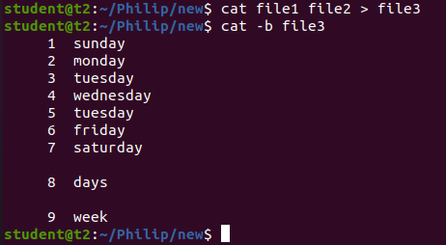

1. Make all contents Upper Case

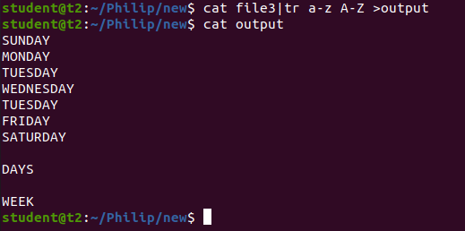

**Result**

The program was executed and the result was successfully obtained. Thus CO2 was obtained